

**Introdução à Ciência da Computação - 113913**

**Gabarito Prova 1.2 – Tipo B**

**Observações:**

* São 20 amostras de entrada e cada amostra de saída correta vale 0.5 ponto.

**Gabarito**

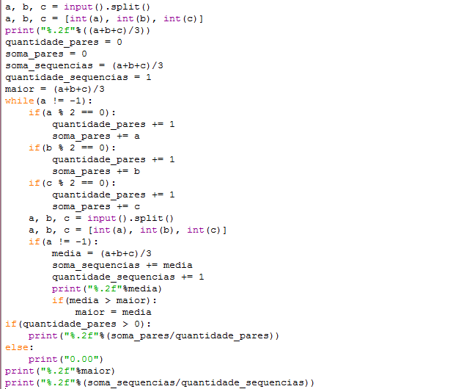

|  |  |
| --- | --- |
| **Amostras de Entrada** | **Amostras de Saída** |
| 3 3 3  5 5 5  7 7 7  -1 2 2 | 3.00  5.00  7.00  0.00  7.00  5.00 |
| 10 2 3  1 1 30  445 7 8  5 365 7  121 111 256  -1 0 0 | 5.00  10.67  153.33  125.67  162.67  61.20  162.67  91.47 |
| 1 1 1  3 3 3  -1 7 8 | 1.00  3.00  0.00  3.00  2.00 |
| 4 5 6  7 8 9  10 11 12  -1 10 10 | 5.00  8.00  11.00  8.00  11.00  8.00 |
| 1 1 2  -2 4 4  -8 9 11  -1 0 10 | 1.33  2.00  4.00  0.00  4.00  2.44 |
| 5 5 6  12 14 15  -18 0 0  -24 10 3  -1 1000 1500 | 5.33  13.67  -6.00  -3.67  0.00  13.67  2.33 |
| 4 4 4  8 8 8  12 12 12  0 0 0  -1 15 14 | 4.00  8.00  12.00  0.00  6.00  12.00  6.00 |
| 3 5 7  3 5 6  8 -98 5  8 98 7  -1 4 6 | 5.00  4.67  -28.33  37.67  4.40  37.67  4.75 |
| -14 5 7  14 -29 -35  -31 -33 -35  -59 60 -60  -1 4 8 | -0.67  -16.67  -33.00  -19.67  0.00  -0.67  -17.50 |
| -40 -80 -120  -2 -1 -1  -3 -1 -5  -8 -2 0  -1 8 74 | -80.00  -1.33  -3.00  -3.33  -36.00  -1.33  -21.92 |
| -4 4 11  0 5 17  -1 0 0 | 3.67  7.33  0.00  7.33  5.50 |
| 1 1 1  3 3 13  5 15 85  -1 -1 -1 | 1.00  6.33  35.00  0.00  35.00  14.11 |
| 1 -1 10  10 5 -1  8 8 8  9 9 9  10 10 10  -1 50 0 | 3.33  4.67  8.00  9.00  10.00  9.25  10.00  7.00 |
| 9 9 81  3 33 55  7 19 17  -1 -1 -100 | 33.00  30.33  14.33  0.00  33.00  25.89 |
| 11 13 17  19 23 31  37 41 11  0 -1 1  -1 0 1 | 13.67  24.33  29.67  0.00  0.00  29.67  16.92 |
| 1 1 1  45 91 111  89 91 93  53 55 57  -1 0 0 | 1.00  82.33  91.00  55.00  0.00  91.00  57.33 |
| -20 -21 -22  -23 -24 -25  -26 -27 -28  -29 -30 -31  -33 -33 -34  -2 -1 0  -1 15 18 | -21.00  -24.00  -27.00  -30.00  -33.33  -1.00  -20.67  -1.00  -22.72 |
| 2 1 1  -1 2 11 | 1.33  2.00  1.33  1.33 |
| 15 17 19  87 89 105  40 46 54  -1000 -1500 -1550  -1001 -1002 -554  -1 0 0 | 17.00  93.67  46.67  -1350.00  -852.33  -683.25  93.67  -409.00 |
| -100 -101 -102  -459 -458 -457  -300 -250 -200  -50 -45 -40  -1 1500 3 | -101.00  -458.00  -250.00  -45.00  -187.50  -45.00  -213.50 |